**2 items addressed here, read the complete 2 pages.**

1. **No AT** **on a non EN OS**

**Error description:**If SiPass 2.70.31 (any language) is installed on a non EN OS the SiPass operation Client will not show any Audit Trail messages.  
Further the Cardholder search is not working search never ends and the Client need to be killed.

**Fix:**  
Inside the zip are two files:

1. No_AT_non_EN_OS_fix_for_2.70.31.bat  
   This batch file offers the possibility to enter the port if the *SiPass server callback port* value changed during setup SiPass
2. 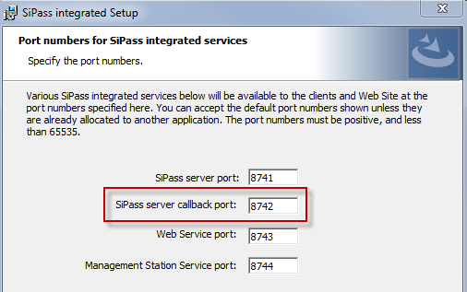No_AT_non_EN_OS_fix_for_2.70.31_default_port.bat  
   This batch file “registers” the default port 8742 and can be used if during the setup the *SiPass server callback port* was not changed.

   
**Unzip PW: spirit**

**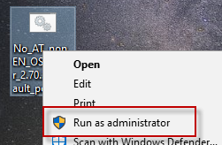  
Note:**The batch file need to be started with right click => Run as Administrator

1. **FLN 3b not working ACC G1 after update to 2.70.23 firmware**

Please be aware that we have a Problem with the old ACC G1 and SiPass MP 2.70 at the moment.

If you use FLN 3a and 3b of the ACC G1 you should not upgrade to ACC 2.70.23 firmware.

Please inform your Technicians about this Problem.

Below you find the FW version 2.70.29 for ACC G1 fixing FLN 3a/3b issue.

