**Date**: 22nd February 2019

# INTRODUCTION

For GTS and Tech support only

This document describes how to configure ACT systems for use with the following range of VR readers with the specified firmware or later.

* VR10 – NGCR Prox only (V.02.003.021)
* VR20 – Mullion Prox only (V2.000.005)
* VR40 – NGCR Pin and Prox (V.02.003.021)
* VR50 – Mullion Pin and Prox (V2.000.005)

To configure the VR Readers, configuration cards are required with the 3CT USB reader tool. These configuration cards may be generated from the files stored at

:\TCC\05_TCC_Data_Exchange\Access GTS Information\3ct Field Files

Difference between V2.0 and V1.x (VR20 & VR50)

* Reads ACT Mifare Classic secure / Non ACT reads UID.
* Absence of jumper J2 selects 37bit wiegand rather than 26bit wiegand.
* Tamper mechanism required to select 26bit wiegand.
* A 7 byte UID transmits bytes 2,3,4 and 5 rather than 4,5,6 and 7 the four LSBytes.
* In wiegand mode idle operation is indicated with a solid amber Led on rather than off.

Difference between VR20,VR50 and VR10,VR40

* Out of the box the VR10 and VR40 read the MF Classic UID and DESFIRE UID
* Out of the box the VR20 and VR50 read the MF Classic secure data on ACT cards and UID on non ACT cards and DESFIRE UID.
* The VR10 & VR40 readers support OSDP only.
* The VR20 & VR50 readers support OSDP and wiegand.

If an ACT Classic card is not presented close enough to the reader it will read the UID rather than the number printed on the card.

**VR Reader is compatible with ACT1520e V1.6.23 or later.**

**VR Reader is compatible with ACT4000 V1.48 or later.**

**VR Reader is compatible with ACTpro100e V1.14 or later.**

**VR Reader is not compatible with ACTpro200.**

# Wiegand Mode (ACT Pro Systems) New Site

The VR20 & VR50 should have the wiegand jumper removed and the three way jumper in the upper position selecting 32bit wiegand mode. The EOL jumper must be removed. See section hardware configuration. The ACT controllers have the 32bit format built in.

**Present the configuration card below, depending on what card type is being used on site:**

|  |  |
| --- | --- |
| **Card Type** | **Configuration Card** |
| ACT Mifare Classic Cards | CC011 |
| ACT DESFire Cards | CC022 |
| Mifare classic UID | CC013 |
| Mifare classic UID reverse byte | CC014 |
| DESfire UID | CC023 |
| DESFire UID reverse byte | CC024 |

To configure ACT Readers for use with the VR Reader:

Wire the ACT reader for Clock and Data mode. (Out of the box reads ACT MF Classic secure or DESFIRE secure dependent on reader type).

**Configure the ACT Reader with the appropriate Jumper settings, depending on what card type is being used on site:**

|  |  |  |
| --- | --- | --- |
| **Card Type** | **ACT Reader** | **Jumper** |
| ACT Mifare Classic Cards | ACT Mifare | Sector (Jumper In Upper Position) |
| ACT DESFire Cards | ACT DESFire | File(Jumper In Upper Position) |
| Mifare classic UID | ACTMifare/ACTDESFire | Serial (Jumper in Lower Position) |
| Mifare classic UID reverse byte | ACTMifare/ACTDESFire | No Jumper |
| DESfire UID | ACTMifare/ACTDESFire | Serial (Jumper in Lower Position |
| DESFire UID reverse byte | ACTMifare/ACTDESFire | No Jumper |

# Wiegand Mode (ACT Pro Systems) Existing Sites with V1.x VR Readers

The V2.00 readers may be configured to behave the same over wiegand as readers with firmware V1.08, V1.09 and V1.12.

The VR20 and VR50 readers must be set for 32-bit Wiegand.

A different configuration card is required for V2.0. See table below for the card types:

|  |  |  |
| --- | --- | --- |
| **Card Type** | **V1.x** | **V2.x** |
| ACT Mifare | CC012 | CC011 |
| ACT Desfire | CC021 | CC022 |
| 4 Byte Mifare UID serial | CC014 | CC013 |
| 4 Byte Mifare UID reverse serial | CC013 | CC014 |

V1.x do not support 7 byte UIDs.

In the latest version of ACT1520e the Check Built In Formats option should be ticked. The 32bit built in option is used.

To configure ACT Readers for use with the VR Reader:

The ACT reader is wired for Clock and Data.

If the ACT reader is configured for Wiegand then the 37bit custom format is required.

**Configure the ACT Reader with the appropriate Jumper settings, depending on what card type is being used on site:**

|  |  |  |
| --- | --- | --- |
| **Card Type** | **ACT Reader** | **Jumper** |
| ACT Mifare Classic Cards | ACT Mifare | Sector Jumper In Upper Position |
| ACT DESFire Cards | ACT DESFire | File(Jumper In Upper Position) |
| Mifare classic UID | ACTMifare/ACTDESFire | Serial Jumper in Lower Position |
| Mifare classic UID reverse byte | ACTMifare/ACTDESFire | No Jumper |

# Wiegand Mode (ACT 365) New Site

ACT365ACU V1.1.17 or later must be used.

|  |  |
| --- | --- |
| **Mode** | **Configuration Card for V2.xx** |
| ACT Mifare Classic Cards | CC011 |
| ACT DESFire Cards | CC022 |
| Mifare classic UID serial mode | CC013 |
| Mifare classic UID in reverse serial mode | CC014 |
| DESfire UID Serial mode | CC023 |
| DESFire UID reverse serial mode | CC024 |

Put VR Reader into 37-bit Wiegand Mode.

The ACT reader may also be put in 37bit wiegand mode.

You must create a new 37 bit format as below (start at bit 5, length 32).

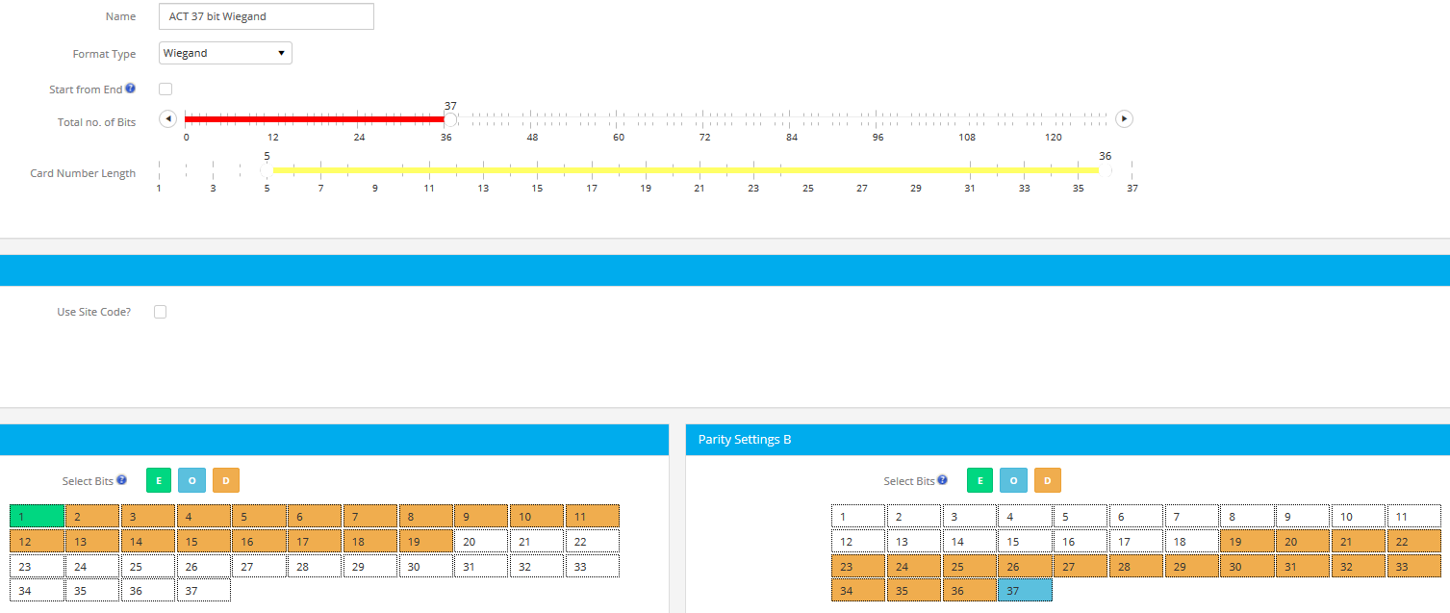

Alternatively the ACT reader may be wired for clock and data.

**Configure the ACT Reader with the appropriate Jumper settings, depending on what card type is being used on site:**

|  |  |  |
| --- | --- | --- |
| **Card Type** | **ACT Reader** | **Jumper** |
| ACT Mifare Classic Cards | ACT Mifare | Sector Jumper In Upper Position |
| ACT DESFire Cards | ACT DESFire | File(Jumper In Upper Position) |
| Mifare classic UID | ACTMifare/ACTDESFire | Serial Jumper in Lower Position |
| Mifare classic UID reverse byte | ACTMifare/ACTDESFire | No Jumer |
| DESfire UID | ACTMifare/ACTDESFire | Serial Jumper in Lower Position |
| DESFire UID reverse byte | ACTMifare/ACTDESFire | No Jumper |

# Wiegand Mode (ACT 365) Existing Site with V1.x Readers

The V2.00 readers may be configured to behave the same over wiegand as readers with firmware V1.08, V1.09 and V1.12.

All VR readers must be set for 32-bit Wiegand.

A different configuration card is required for V2.0. See table below for the Card types:

|  |  |  |
| --- | --- | --- |
| **Card Type** | **V1.x** | **V2.x** |
| ACT Mifare | CC012 | CC011 |
| ACT Desfire | CC021 | CC022 |
| 4 Byte Mifare UID serial | CC014 | CC013 |
| 4 Byte Mifare UID reverse serial | CC013 | CC014 |

V1.x Readers do no support 7 byte UIDs.

Configure the following 32-bit custom card format on ACT365:

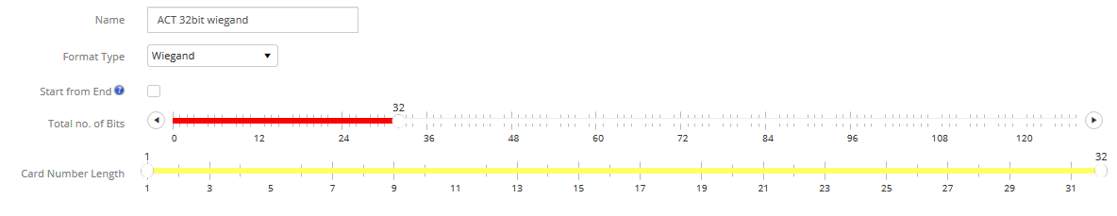

To configure ACT Readers for use with the VR Reader wire the reader for wiegand operation.

Alternatively the reader may be wired for clock and data operation.

**Configure the ACT Reader with the appropriate Jumper settings, depending on what card type is being used on site:**

|  |  |  |
| --- | --- | --- |
| **Card Type** | **ACT Reader** | **Jumper** |
| ACT Mifare Classic Cards | ACT Mifare | Sector Jumper In Upper Position |
| ACT DESFire Cards | ACT DESFire | File(Jumper In Upper Position) |
| Mifare classic UID | ACTMifare/ACTDESFire | Serial Jumper in Lower Position |
| Mifare classic UID reverse byte | ACTMifare/ACTDESFire | No Jumper |

# OSDP Mode (ACT Pro Systems)

The VR20 and VR50 readers are configured for OSDP operation out of the box with the reader set for OSDP address 1.

1. ACTPro1520e v1.6.23 or later

OSDP mode is **not** supported on ACTpro4000, ACTpro100 or ACTpro200 door stations.

|  |  |
| --- | --- |
| **Mode** | **Configuration Card** |
| ACT Mifare Classic Cards | CC011 |
| ACT DESFire Cards | CC022 |
| Mifare classic UID serial mode | CC013 |
| Mifare classic UID in reverse serial mode | CC014 |
| DESfire UID Serial mode | CC023 |
| DESFire UID reverse serial mode | CC024 |

# OSDP Mode (ACT 365)

OSDP mode is not supported on ACT365.

# VR READER HARDWARE CONFIGURATION

**OSDP Mode**

The VR reader may be hardware configured for OSDP operation by placing a link on Jumper 1 as shown. Jumper 3 connects and End-Of-Line (EOL) resistor. Jumper 3 is inserted if the reader is the last in a daisychain from the controller.

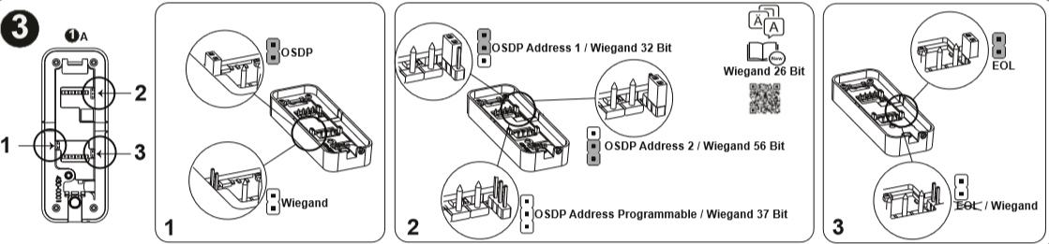

**Wiegand Mode**

To configure the reader for wiegand mode remove Jumper 1 and Jumper 3. 32 / 56 and 37bit operation may be assigned according to the setting of Jumper 2 as shown above. The reader may be configured for 26 bit wiegand mode by following the instructions below.

# 26 bit Wiegand Operation

The reader may be put into 26-bit wiegand mode as follows;

1. Connect Red input to the Tamper
2. Put Jumper 2 in the lower position,
3. Tamper input activated (remove back plate)
4. Remove OSDP Jumper 1
5. Power up reader
6. Reader beeps an affirmation tone and the RED indication led flashes each second.
7. Power down the reader.
8. Disconnect Red input and tamper connection.
9. Power up the reader
10. It now operates in 26bit wiegand mode regardless of the setting of Jumper 2.

# Wiegand Bit Mode Selected by Jumper 2

To reverse the reader out of 26 bit mode and to use the setting of J2 follow the steps below:

1. Connect Red input to the Tamper
2. Remove J2
3. Tamper input activated (remove back plate)
4. Remove OSDP jumper J1
5. Power up reader
6. Reader beeps an affirmation tone and the RED indication led flashes each second.
7. Power down the reader.
8. Disconnect Red input and tamper connection.
9. Place jumper J2 in the appropriate position for the number of Wiegand bits (Upper position for 32bit, lower position for 56bit and absent for 37bit.
10. Power up the reader.

The RED indication LED flashes twice on a power up if the reader is configured for 26bit wiegand operation.

# Backwards Compatibility Over Wiegand

To provide backwards compatiblity to V1.08, 1.09 and 1.12 VR readers, the reader may be put into a mode to reverse the data transmission sequence in Wiegand mode (‘Reverse Wiegand’).

* 1. Connect Green to the Tamper connection
  2. Put J2 in the lower position,
  3. Tamper input activated (remove back plate)
  4. Remove OSDP jumper J1
  5. Power up reader
  6. Reader beeps an affirmation tone and the GREEN indication led flashes each second.
  7. Power down the reader.
  8. Disconnect Green input and tamper connection.
  9. Place jumper J2 in the appropriate position for the number of Weigand bits (Upper position for 32bit, lower position for 56bit and absent for 37bit).
  10. Power up the reader

The GREEN indication LED flashes twice on power up if the reader is configured for ‘Backwards compatibility over wiegand’.

Note: Both RED & GREEN indication LEDs flash twice simultaneously on power up if the reader is configured for both ‘Backwards compatibility over wiegand’ and for 26bit wiegand mode.

# Standard Wiegand Operation

To put the reader back into the orignal data sequence for Wiegand (‘Standard Wiegand’) follow the steps below:

1. Connect Green to the Tamper connection
2. Remove J2,
3. Tamper input activated (remove back plate)
4. Remove OSDP jumper J1
5. Power up reader
6. Reader beeps an affirmation tone and the GREEN indication led flashes each second.
7. Power down the reader.
8. Disconnect Green input and tamper connection.
9. Place jumper J2 in the appropriate position for the number of Weigand bits (Upper position for 32bit, lower position for 56bit and absent for 37bit).
10. Power up the reader

# Default Configuration

The Default Configuration card configures the reader for

1. Standard Wiegand transmission mode,
2. Wiegand bit mode dependent on J2,
3. ACT Mifare card printed number on card,
4. DESfire UID.

# bit Wiegand Operation

Configure 37bit Custom Card format in ACTEnterprise as shown below:

